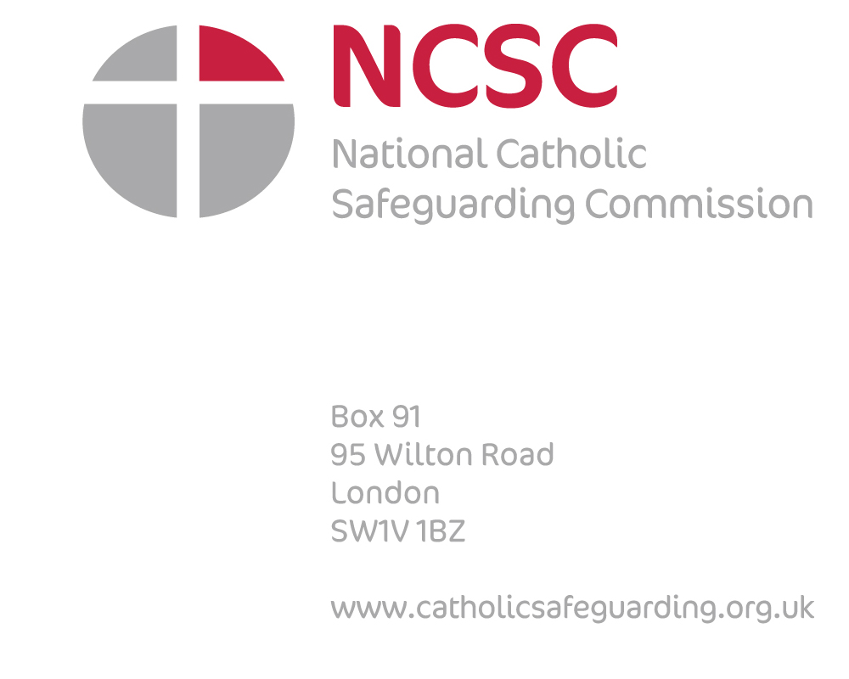

September 2016

National Catholic Safeguarding Commission (NCSC) Press Release,

**The National Catholic Safeguarding Commission has today published its annual report.**

**Highlights:**

**National Pastoral Support Service.**  aims to help victims and survivors access whichever support and services that they need. A pilot project was run in Hallam and it is hoped that a similar service will be set up in different parts of the country.

**The Survivors Advisory Panel.** In its first year, the panel’s input has been invaluable, and will help inform the future work of the Commission.

**The Annual Anglophone Episcopal Safeguarding Conference.** This was held in Rome in June, and led jointly by England and Wales, and Kenya. The conference theme was “Listening”, and conference speakers included survivors of abuse who shared their experiences of not being listened to by the Church.

**The E-learning safeguarding programme launched last year** is available to all members of the Catholic Community in England and Wales, free of charge. To date 3200 learners have registered on each of the seven modules.

**This is the 12th year we have collected and published safeguarding data.** The NCSC is overseeing the piloting of a national electronic recording system of data.

**Development of a Quality Assurance Framework (QAF).** It is recognised that the data collection needs to have a more outcome focused approach so there is a story to tell about the effectiveness in bringing about improvements in safeguarding and prevention. A working group is already tasked with progressing a QAF taking into account experiences of key stakeholders which will determine what outcomes have been achieved and whether services have been effective.

**The Chair of the National Catholic Safeguarding Commission, Chris Pearson**:

“*Safeguarding is everyone’s business and it is not just a procedural process or duty. It must be at the centre of the Church’s mission that sees in action that victims and survivors of abuse are at the heart of what we do* *This report highlights in full the work of the Commission and this announcement is just a snapshot of some of that work and findings over the last year. As a result, we are moving towards a much more consistent and sensitive approach in response to the victims and survivors of abuse*.”

A copy of the annual report can be downloaded from: [www.catholicsafeguarding.org.uk](http://www.catholicsafeguarding.org.uk)

**-Ends-**

**National Catholic Safeguarding Commission**

The National Catholic Safeguarding Commission (NCSC) is an independent body working within the framework of the Catholic Church in England and Wales. It is mandated by the Conference of Bishops and Conference of Religious Congregations and has accountability across Dioceses and Religious Congregations to ensure that standards are met and policies are implemented.

Established in 2008 the NCSC sets the strategic direction of the Church’s safeguarding policy for children and vulnerable adults. It also monitors and audits the compliance of the Church with safeguarding procedures. The NCSC has sixteen members who bring together a wide range of knowledge, skill and expertise in safeguarding matters, and in state and canon law. For further details see www.catholicsafeguarding.org.uk

**For further information or to arrange an interview contact:**

Email: [bernadette.speakman@catholicsafeguarding.org.uk](mailto:bernadette.speakman@catholicsafeguarding.org.uk)

Phone: 07530 972830